Frequent fire in northern California chaparral reduces post-fire shrub regeneration and native plant diversity

Grupenhoff, A & Safford, HD

# Abstract

Like most of the western US, fire is an essential driver in maintaining species diversity and resilience in chaparral-dominated shrublands. Historically chaparral burned at high intensity and had long intervals between fires. However, fire frequency has increased exponentially in this ecosystem with the rise of urbanization and an extended fire season. This departure has severe effects on biodiversity leading to exotic invasion and type conversion of shrubland to grassland. This has been well studied in southern California, but the timing and mechanisms of this process are poorly understood in northern California. This study examines how fire frequency affects the composition and abundance of herbaceous and woody species in the Coast Range of northern California, one of the most frequently burned areas in the whole state. This study takes place on the LNU lightning complex in the coast range of northern California, one of the most frequently burned locations in the whole state. Fifty-four 250-m2 plots were surveyed in 2021 and 2022 to measure changes in plant community composition and postfire regeneration of chaparral shrubs across a large gradient of fire frequency, up to six total fires in the last 20 years.

# Introduction

Fire is vital in maintaining biodiversity in many fire-adapted ecosystems across the western US, but interactions between anthropogenic drivers such as global climate change and land use are reshaping these areas worldwide. In chaparral systems, we are seeing a hotter and drier climate leading to more extreme fire weather (Abatzoglou and Williams 2016; Bruegger et al. 2016) and urbanization increasing the number of human ignitions (cite). These changes in climate and ignitions have altered the natural fire regime across the region.

California chaparral burns at high intensity and historically had long intervals between fire, with a fire return interval of 20-100 years prior to Euro-American settlement (Van de Water and Safford 2011). However, fire frequency has exponentially increased in this system with the rise of urbanization and an extended fire season (Westerling and Bryant 2008). This departure in fire frequency from historic norms has many implications for plant communities and often leads to exotic invasion and conversion to grassland (D’Antonio and Vitousek 1992; Keeley 2004). Some studies have examined the effects of increased fire frequency in southern California but to date, no study has examined these effects at sites that have burned up to five times. Additionally, only a handful of studies have focused on the Coast Range of northern California, one of the most frequently burned locations in the whole state.

Native chaparral shrublands of California provide critical ecosystem service, however, uncharacteristically short fire return intervals threaten chaparral. An increase in fire frequency has the potential to decrease plant diversity by eliminating species without adaptations to short fire return intervals. Many plants adapted to fire-prone ecosystems have traits that allow them to survive and regrow after fire or to rapidly recolonize burned areas (He et al. 2019). When a community experiences increased fire frequency, plants without traits that allow them to survive fire may not have enough time to colonize, establish, and mature before fire returns (Eldridge & Bradstock, 1994). This means that fire can act as an evolutionary filter against certain traits, such as woody growth. A change in fire history patterns may have more complex implications on the vegetative community and can ultimately lead to type conversion to a different community (Pausas et al. 2004, Keeley and Zedler 1998).

Shifts in composition and type conversion have large-scale implications on ecosystem resilience, the regions’ biodiversity, and ecosystem services such as primary productivity, and nutrient cycling (Rundel 2018). Understanding the nuanced effects of fire recurrence on biodiversity and species composition is necessary for understanding future trajectories of chaparral type conversion. Once a community has undergone type conversion, it has a very low

chance of reverting back to its historical condition, even if actively managed. Identifying areas

that are in severe danger of type conversion, but are still intact, opens the possibility for

preventative management. The direct impacts of climate change can also lead to changes in

vegetation communities. However, changed fire patterns can accelerate, and in some instances,

may be even more important than direct changes as a result of climate (Pausas et al. 2004,

Flannigan et al. 2000).

This study takes place on the LNU Lightning Complex (Hennessey) fire scar, one of the largest fires in California’s history and one of the most frequently burned locations in the whole state. This fire occurred in late August 2020, burning just over 360,000 acres in Napa, Lake, Sonoma, Yolo, and Solano counties. Over half of the fire perimeter had prior fire within 30 years of the LNU Lightning Complex, with some of these areas burning up to 7 times in the past 20 years. Despite the prevalence of increased fire recurrence in northern California chaparral, no studies have examined these impacts across a full gradient of fire frequency, up to seven total fires in the last 20 years. Although some studies have looked at these implications in southern California, these areas are too degraded to prevent further loss of ecosystem services. To understand when northern California chaparral communities lose resilience to invasion, we asked two primary questions: 1) How does fire frequency affect the diversity and cover of native and nonnative species and 2) What are the consequences of higher burn frequency on shrub seedling establishment and resprout success. Similar to studies in southern California, we hypothesized (1) a reduction in species diversity and local richness in areas with more than 2 short interval fires and (2) decreased native shrub regeneration and resprout growth of native shrubs.

# Methods

***Study Site and Sampling Design:***

Post-fire plant communities were sampled after the LNU Lightening complex in chaparral shrublands of Northern California. The LNU Lightning Complex Fire was the sixth-largest fire in California history (as of February 2023). In total, it burned 363,220 acres between August and October 2020 across Colusa, Lake, Napa, Sonoma, Solano, and Yolo Counties (CITE CALFIRE).

In total, 54 plots were implemented at Quail Ridge UC Natural Reserve, Cold Canyon UC Natural Reserve, Cache Creek Regional Park, and Bobcat Ranch Audubon Reserve (Fig. 1). This area has a variable fire history, ranging from never burned to six prior burns in the past 20 years (Table 1). Plot locations were stratified across a fire frequency gradient and aspect, choosing an equal number of plots on north and south-facing slopes.GIS layers from the USDA Forest Service were used to extract the date of origin and fire size for fires that occurred during the past 30 years. Fire frequency was calculated using the California Fire Return Interval Departure database.

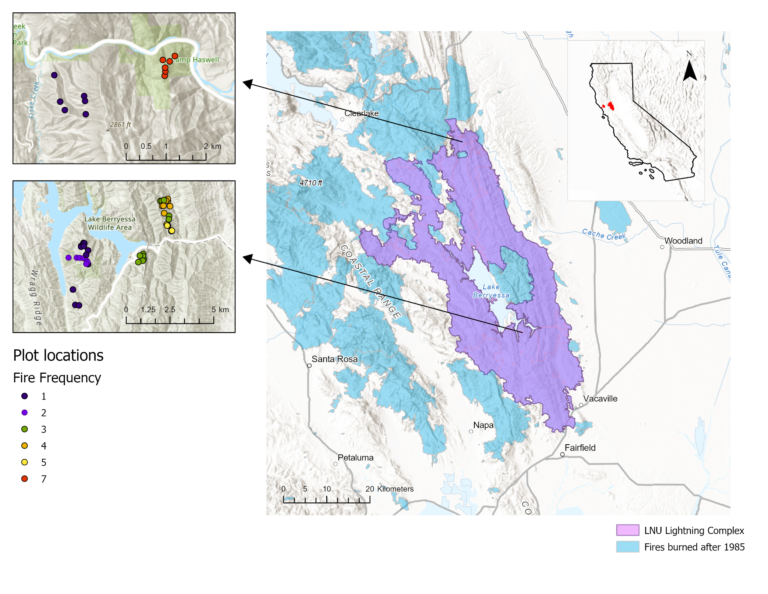

*Fig. 1. Map of LNU Lightning complex (purple polygon) with locations of prior fires burned since 1985 (light blue polygons). The figures to the left show plot locations, which were distributed across a fire frequency gradient of 1 total burn (blue) up to 7 total burns in the past 20 years (red).*

Table 1: Study sites across the LNU Lightning Complex

| Site | Jurisdiction | Fire History (since 1990) | Shortest interval between fire | Fire frequency (since 1990) |
| --- | --- | --- | --- | --- |
| Bobcat Ranch | Audubon Canyon Ranch | 2020 (Hennessey), 2018 (County), 2016 (Cold), 2014 (Monticello), 2007 (Braye) | 2 | 4-5 fires |
| Quail Ridge | UC Natural Reserve | 2020 (Hennessey), 2005 (Pleasure) | 15 | 1-2 |
| Cold Canyon | UC Natural Reserve | 2020 (Hennessey), 2015 (Wragg) | 5 | 3 |
| Cache Creek | BLM | 2020 (Hennessey), 2012 (sixteen), 2006 (rumsey), 2004 (rumsey), 2002 (sixteen) | 2 | 1 & 7 |

At each of the 54 plots, 50 x 5-m belt transects were established following Safford and Harrison (2004). Sites were visited in the spring of 2021 and 2022. All plant species were recorded within the entire 250-m2 transect to measure the richness and diversity of native and exotic plant species. Five 1-m2 quadrats will be sampled at 10-m intervals along the transect line, measuring: the percentage of all native and exotic species; number and heights of shrub seedlings; percentage cover of rock, bare soil, and litter; and litter depth. All variables collected at the 1-m2 scale were averaged to give a plot-level value.

Fire severity was estimated at each plot by measuring the stem diameter (1 cm from the terminus) of four stems from 10 randomly chosen *Adenostoma fasciculatum* (chamise) individuals (Perez and Moreno 1998). In cases when chamise was not present we used *Heteromeles arbutifolia* or *Quercus berberidifolia* individuals.

Plant life history data for each species was obtained from the USDA Forest Service Fire Effects Information System or the University of California Jepson Herbarium. Species were classified to origin (native, nonnative), lifecycle (perennial, annual), lifeform (tree, shrub, forb, graminoid, fern), and fire regeneration strategy (invader, seeder, resprouter, avoider) using the Raunkiaer (1934) classification system

***Statistical analyses***

*Species cover, diversity, and composition*

Bayesian generalized linear mixed models were used to investigate the interaction between fire frequency on the proportion of native species richness and cover using a Beta Binomial likelihood (Equation 1), which accommodates values between 0 and 1, for both survey years. To determine which environmental covariates to add to the model, we used the expected log pointwise predictive density (ELPD) as a measure of leave-one-out cross-validation for our goodness of fit measure. The covariates that we evaluated were fire frequency (numBurn), mean annual precipitation, mean annual temperature, heat load index, and aspect. We verified that independent variables were not highly correlated (ADD FIGURE SUPPLEMENT). We first fit the proportion of native species cover with each individual predictor separately and added significant predictors in order of ELPD to determine whether they significantly increased ELPD of the resulting model.

*Equation 1:*

$prop.nativecover_{i,j} \sim Beta(μ_{i,j },ϕ)$

$logit(μ_{i,j }) = α + β_{numBurn}numBurn + β_{SurveyYear}SurveyYear$

$α \sim student_t(3, 0, 2.5)$

Non-metric multidimensional scaling (NMDS) was used to visualize compositional differences between areas with variable fire recurrence as a part of the ‘vegan’ package in R (Oksanen et al. 2011). This ordination uses rank-order correlation and Bray-Curtis dissimilarities to model the differences among treatments based on species composition and abundance of all plant species.

*Shrub regeneration*

We used a similar modeling procedure to understand how fire frequency influenced shrub regeneration. We fit seedling presence/absence using multiple Bayesian generalized linear models with Bernoulli likelihood (Equation 2). Similarly to species diversity, we used the ELPD as a measure of leave-one-out cross-validation for our goodness of fit measure to compare. We first fit the presence/absence of a seedling with each individual predictor separately and added significant predictors in order of ELPD to determine whether they significantly increased ELPD of the resulting model. The covariates that we evaluated were fire frequency (numBurn), mean annual precipitation, mean annual temperature, heat load index, and aspect. A separate model for facultative and obligate seeding species, and for each individual species separately.

Equation 2:

$presence \sim Bernoulli(ρ_{i})$

$logit(ρ_{i}) = α +β_{numBurn}numBurn +β_{SurveyYear}SurveyYear$

$a \sim student_t(3, 0, 1)$

All models were created using the brm function in the brms package (Burkner 2017) in R version 4.1.1 (R Development Core Team 2022). Continuous independent variables were centered and scaled prior to analysis. We used mildly regularizing priors to prevent overfitting with used 4 chains, each with 2000 iterations and a warmup of 1000. Trace plots and R-hat values were assessed to confirm proper mixing and model convergence.

# Results

*Fire severity*

Mean and maximum fire severity, as well as the heterogeneity of fire severity, were reduced in areas with short interval fire (>2 in the past 20 years) (Fig. 2, Table 2).

*Species cover, diversity, and composition*

In total, 223 species were found throughout the study area. As predicted, we found that the proportion of native species cover, richness, and Shannon diversity declined with increased fire recurrence in both survey years (Fig. 3). The effect of fire recurrence was strongest for the proportion of native cover (βnumburn = -0.51; CIs = -0.65 to -0.37) and moderately strong for the proportion of native species richness (βnumburn = -0.19; CIs = -0.27 to -0.11) and Shannon diversity (βnumburn = -0.19; CIs = -0.28 to -0.09) (Tables 3a-3c).

Plots in areas with different fire frequencies had different species assemblages. The NMDS ordination of species composition resulted in an overlapping cluster of plots with higher fire recurrence (>2 short interval fires) that contain more nonnative herbaceous species, while plots with lower fire recurrence (≤ 2 short interval fires) contained more native herbaceous species and shrubs (Fig. 4). Plots with higher fire recurrence had smaller cluster compared to areas with low fire recurrence, designating a shift from a more heterogeneous post-fire landscape to a homogeneous landscape with many similar nonnative species.

*Shrub regeneration*

Uncharacteristically short fire return intervals in northern California chamise chaparral reduced native woody regeneration (Fig. 5). Overall, facultative seedling regeneration declined by 83% and obligate seedling regeneration declined by 99% in the most highly departed plots (fire recurrence = 7). Obligate species, including *Ceanouthus oliganthus* and *Ceanthous cuneatus,* were almost completely eliminated in areas with >2 fires in the past 20 years (Fig.6). We found a strong association between fire frequency and the occurrence of obligate seeder regeneration (βnumburn = -0.85; CIs = -1.36 to -0.45) and a significant, albeit less strong, association between fire frequency and the occurrence of facultative seedling regeneration (βnumburn = -0.19; CIs = -0.32 to -0.06). Although we found moderate evidence for the negative influence of increased fire frequency on facultative seedling regeneration, this trend was species-specific (Fig. 7). Fire frequency significantly reduced the occurrence of *Adenostoma fasciculatum* (βnumburn = -0.54; CIs = -0.86 to -0.06) and *Lepechinia calycina* seedlings(βnumburn = -0.41; CIs = -0.77 to -0.11). We found a slight increase in *Eriodictyon californicum* seedlings(βnumburn = 0.07; CIs = -0.14 to 0.27), however, this effect was not significant.

Table 2: Measures of fire severity (mm) (± SE) across fire frequency gradient.

| Fire frequency | 1 | 3 | 4 | 5 | 7 |
| --- | --- | --- | --- | --- | --- |
| Mean fire severity (mm) | 1.17 ± 0.24 | 0.24 ± 0.03 | 0.13 ± 0.01 | 0.22 ± 0.02 | 0.32 ± 0.02 |
| Coefficient of variation in mean fire severity (%) | 83.1 | 37.9 | 20.3 | 21.1 | 16.7 |
| Maximum fire severity (mm) | 2.45 ± 0.48 | 0.49 ± 0.07 | 0.21 ± 0.03 | 0.40 ± 0.04 | 0.47 ± 0.02 |
| Coefficient of variation in maximum fire severity (%) | 78.4 | 47.2 | 34.6 | 23.1 | 10.3 |

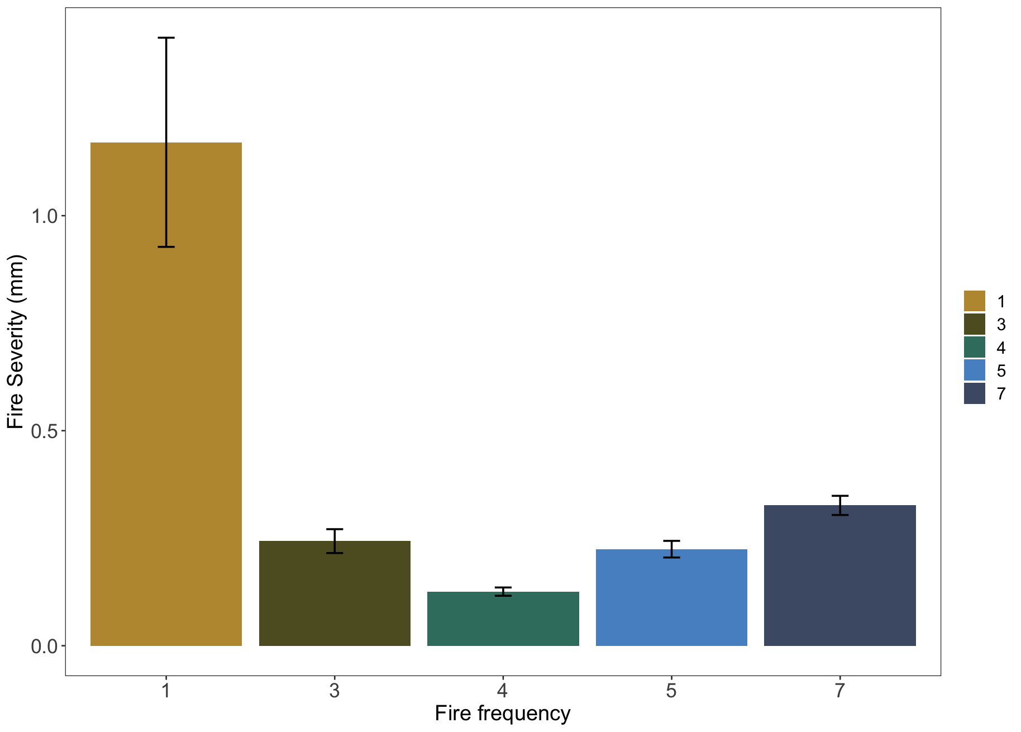

*Fig 2: Measures of mean fire severity (mm) (± SE) decrease with multiple short-interval fires.*

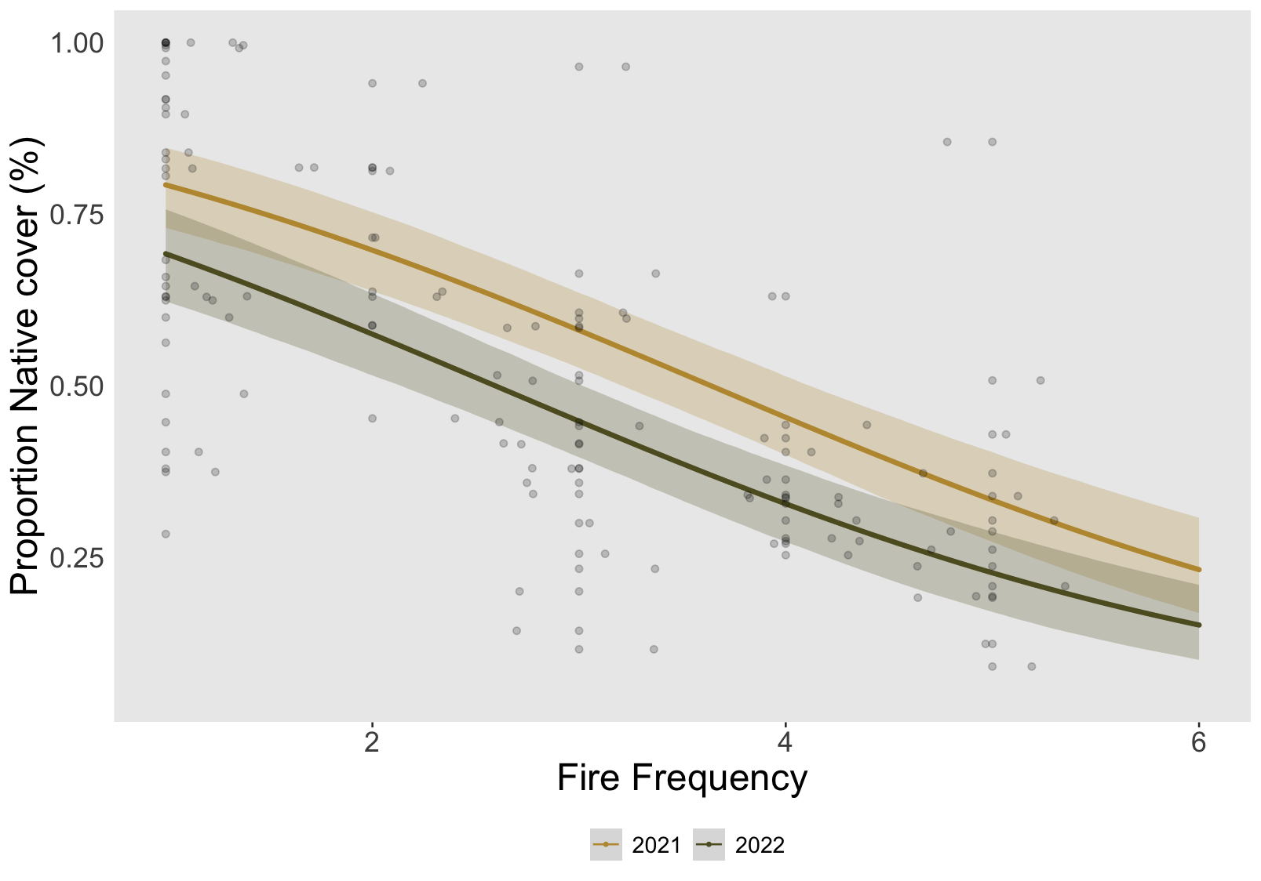

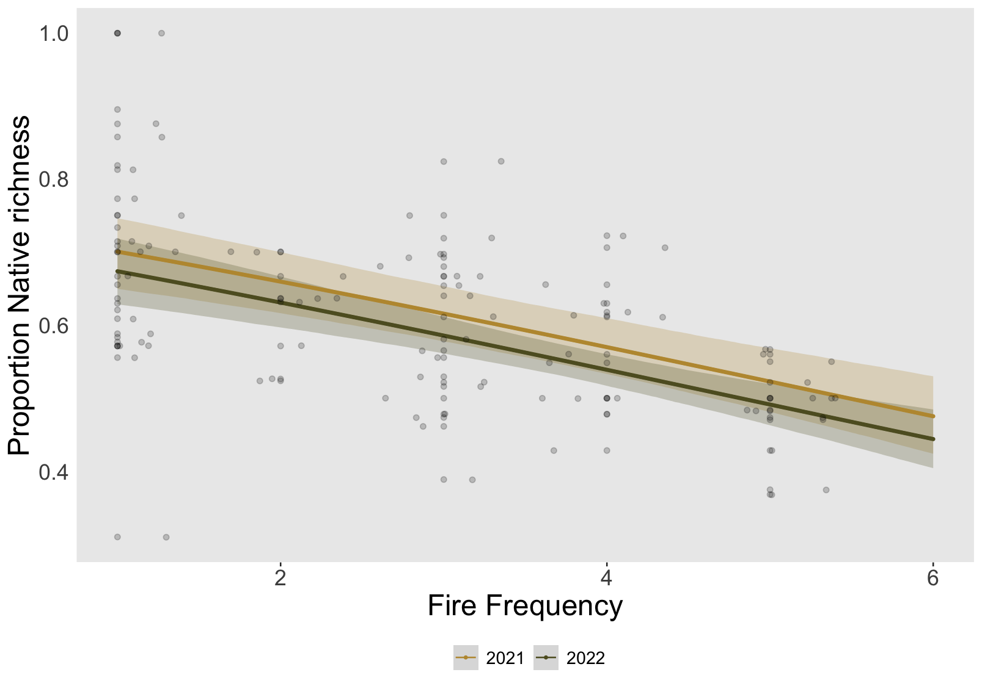

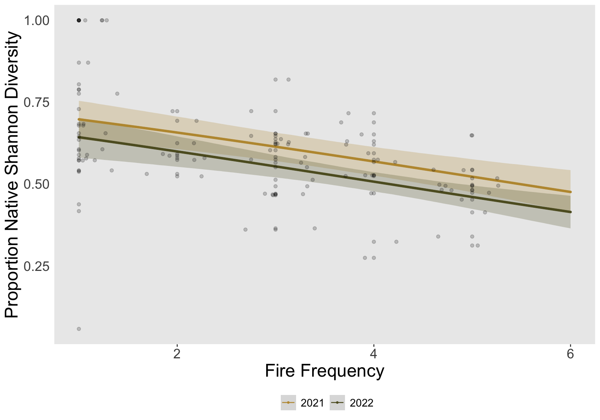

*Fig 3: Proportion of native species cover (A), richness (B), and Shannon diversity (C) at the plot level declines with increased fire frequency. Predicted values from the top-ranked Bayesian model with 95% credible intervals, as well as raw values (grey circles, n=103).*

*Table 3a: Model summary for Bayesian model fit for the proportion of native species cover.*

|  | Estimate | Est.Error | Lower 95% CI | Upper 95% CI | Rhat | Bulk_ESS |
| --- | --- | --- | --- | --- | --- | --- |
| Intercept | 1.86 | 0.28 | 1.29 | 2.41 | 1.00 | 3158 |
| Num_burn | -0.51 | 0.07 | -0.65 | -0.37 | 1.00 | 3349 |
| 2022 SurveyYear | -0.54 | 0.19 | -0.91 | -0.16 | 1.00 | 4537 |

*Table 3b: Model summary for Bayesian model fit for the proportion of native species richness at the plot level.*

|  | Estimate | Est.Error | Lower 95% CI | Upper 95% CI | Rhat | Bulk_ESS |
| --- | --- | --- | --- | --- | --- | --- |
| Intercept | 1.04 | 0.17 | 0.70 | 1.38 | 1.00 | 2407 |
| Num_burn | -0.19 | 0.04 | -0.27 | -0.11 | 1.00 | 2410 |
| 2022 SurveyYear | -0.13 | 0.11 | -0.35 | 0.09 | 1.00 | 3194 |

*Table 3c: Model summary for Bayesian model fit for the proportion of native species Shannon diversity at the plot level.*

|  | Estimate | Est.Error | Lower 95% CI | Upper 95% CI | Rhat | Bulk_ESS |
| --- | --- | --- | --- | --- | --- | --- |
| Intercept | 1.03 | 0.21 | 0.61 | 1.44 | 1.00 | 2267 |
| Num_burn | -0.19 | 0.05 | -0.28 | -0.09 | 1.00 | 2379 |
| 2022 SurveyYear | -0.25 | 0.13 | -0.52 | -0.01 | 1.00 | 3215 |

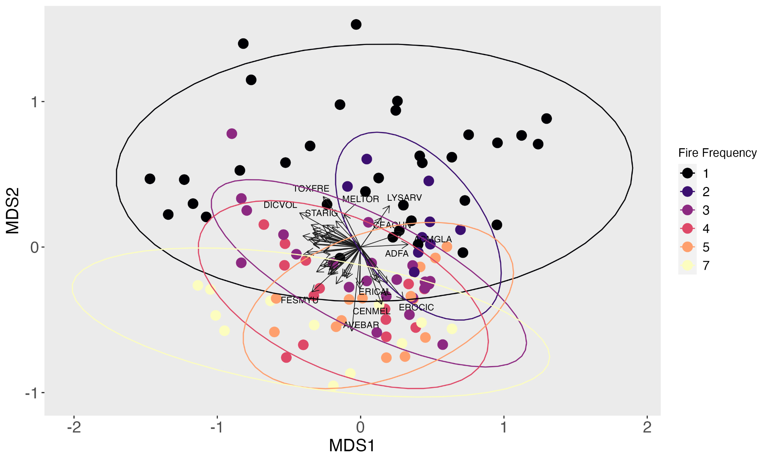

​​

*Fig 4: Non-metric multidimensional scaling plot (NMDS) of Bray-Curtis dissimilarity matrix across fire frequency. Each point represents a survey point. Plots with higher fire recurrence (pink, orange, and yellow) are more clustered together, indicating that they have a more similar species composition than plots with lower fire recurrence (black, purple, dark blue). Labeling priorty was given to more abundant and frequent species. Species codes:* ACMGLA *Acmispon glaber,* ACMWRA *Acmispon wrangelianus,* ADFA *Adenostoma fasciculatum,* ASTGAM *Astragalus gambelianus,* AVEBAR *Avena barbata,* CEACUN *Ceanothus cuneatus,*CENMEL *Centaurea melitensis,* CLAUNG *Clarkia unguiculata,* DICVOL *Dichelostemma volubile,* ERICAL *Eriodictyon californicum,* EROCIC *Erodium cicutarium, ESCCAE Eschscholzia caespitosa,* FESMYU *Festuca myuros,* LYSARV *Lysimachia arvensis,* MELTOR *Melica torreyana,* NEMMEN *Nemophila menziesii,* STARIG *Stachys rigida,* TOXFRE *Toxicodendron fremontii,* TRIMIC *Trifolium microcephalum,* TRIMIC2 *Trifolum microdon. Final stress of three dimensional solution = 0.166 after 24 iterations.*

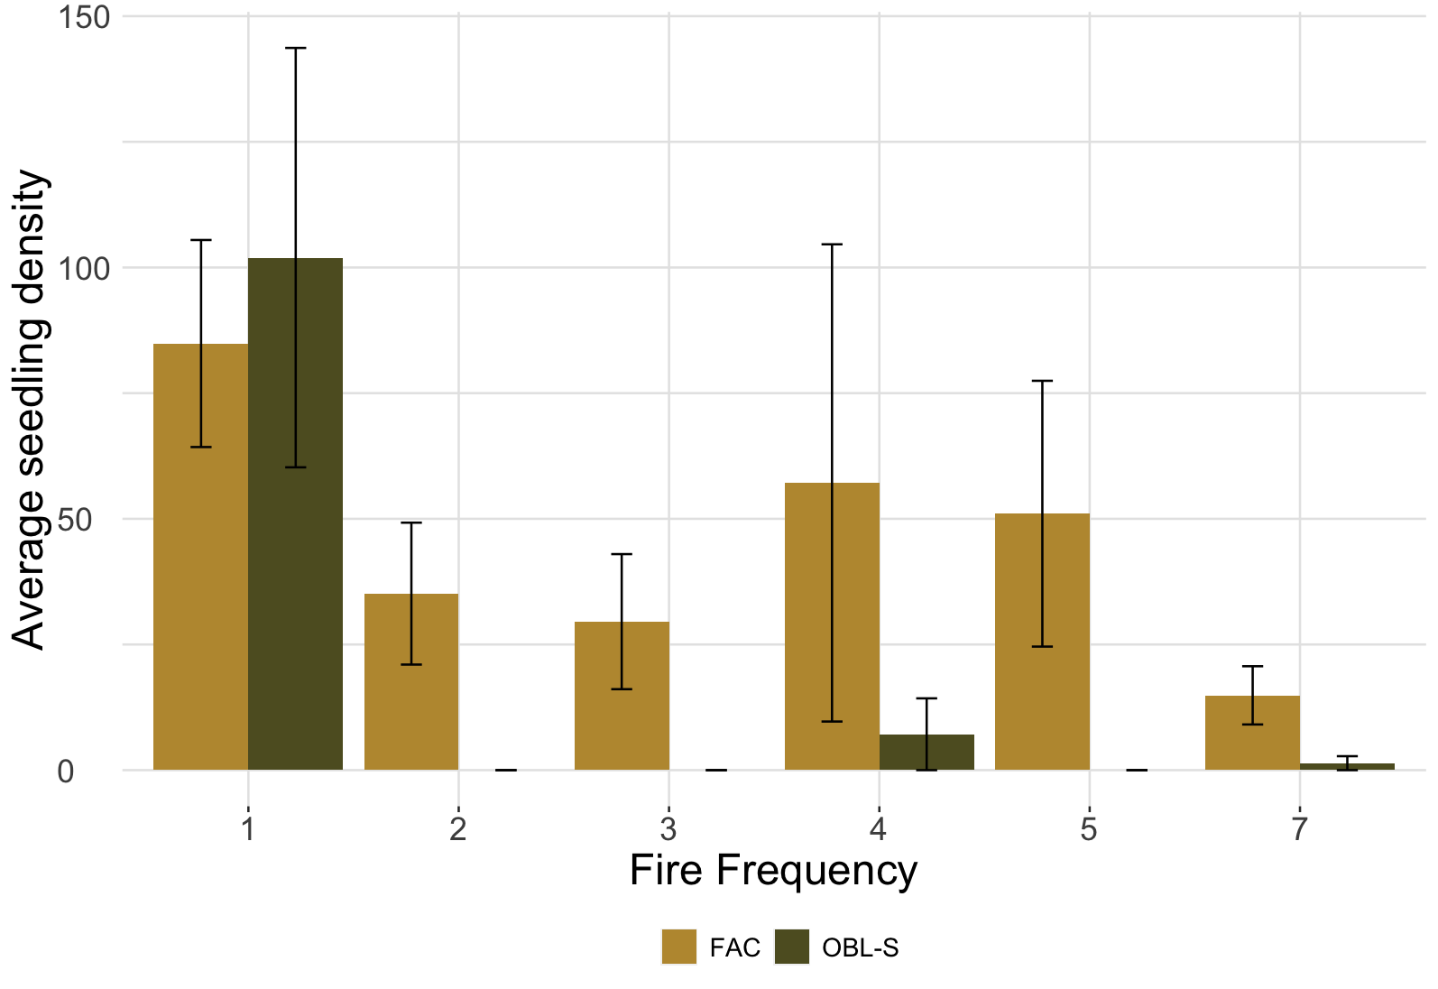

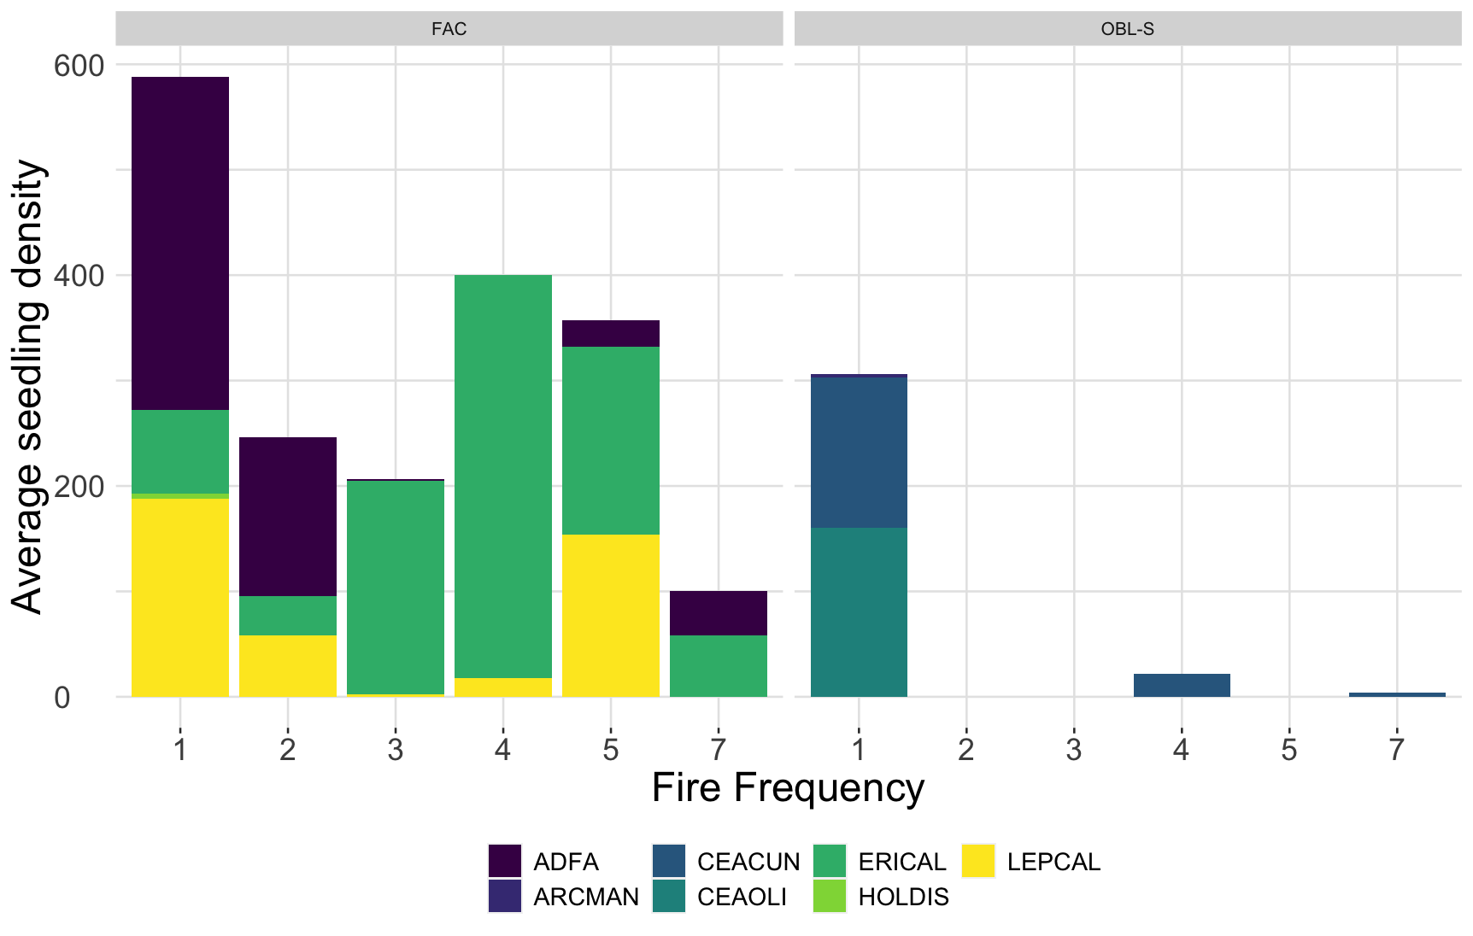

*Figure 5: A) Average seedling density (number/250 m2 plot) (± SE) with increasing fire frequency for facultative (yellow) and obligate seeding (green) species. B) Seedling density (number/250 m2 plot) across fire frequency gradient averaged by species. Plant codes: ADFA - Adenostoma fasciculatum; ARCMAN - Arctostaphylos manzanita; CEACUN - Ceanothus cuneatus; CEAOLI - Ceanothus oliganthus; ERICAL - Eriodictyon californicum; HOLDIS - Holodiscus discolor; LEPCAL - Lepechinia calycina*

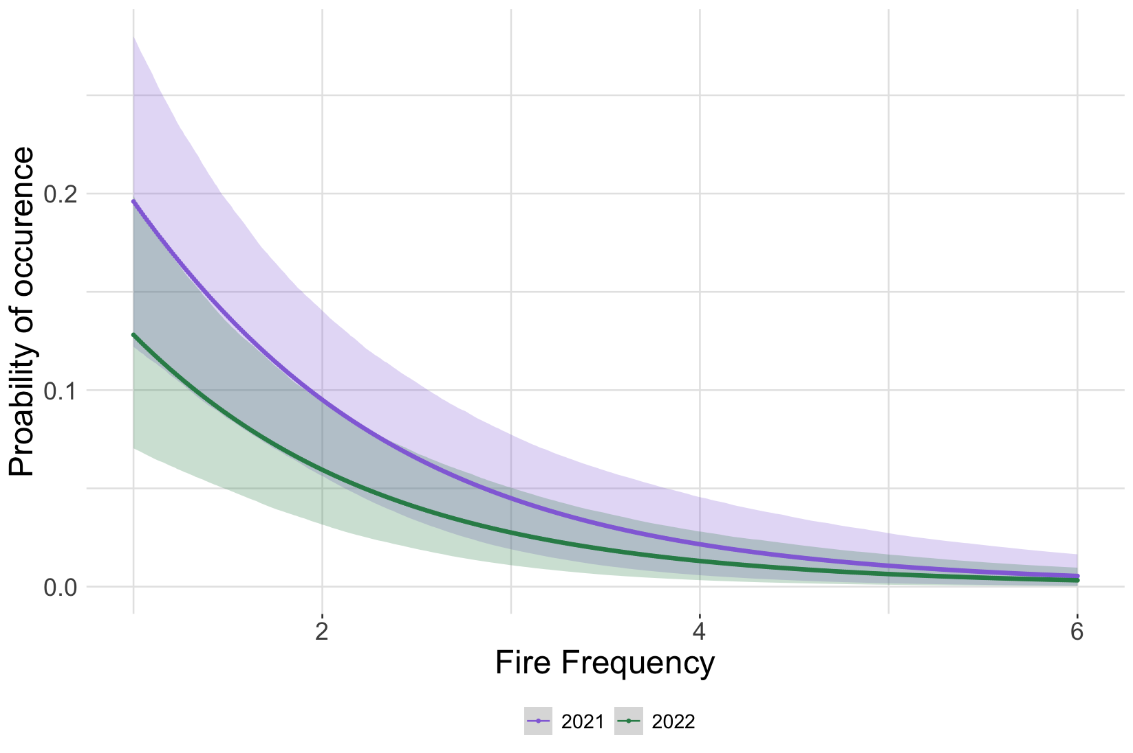

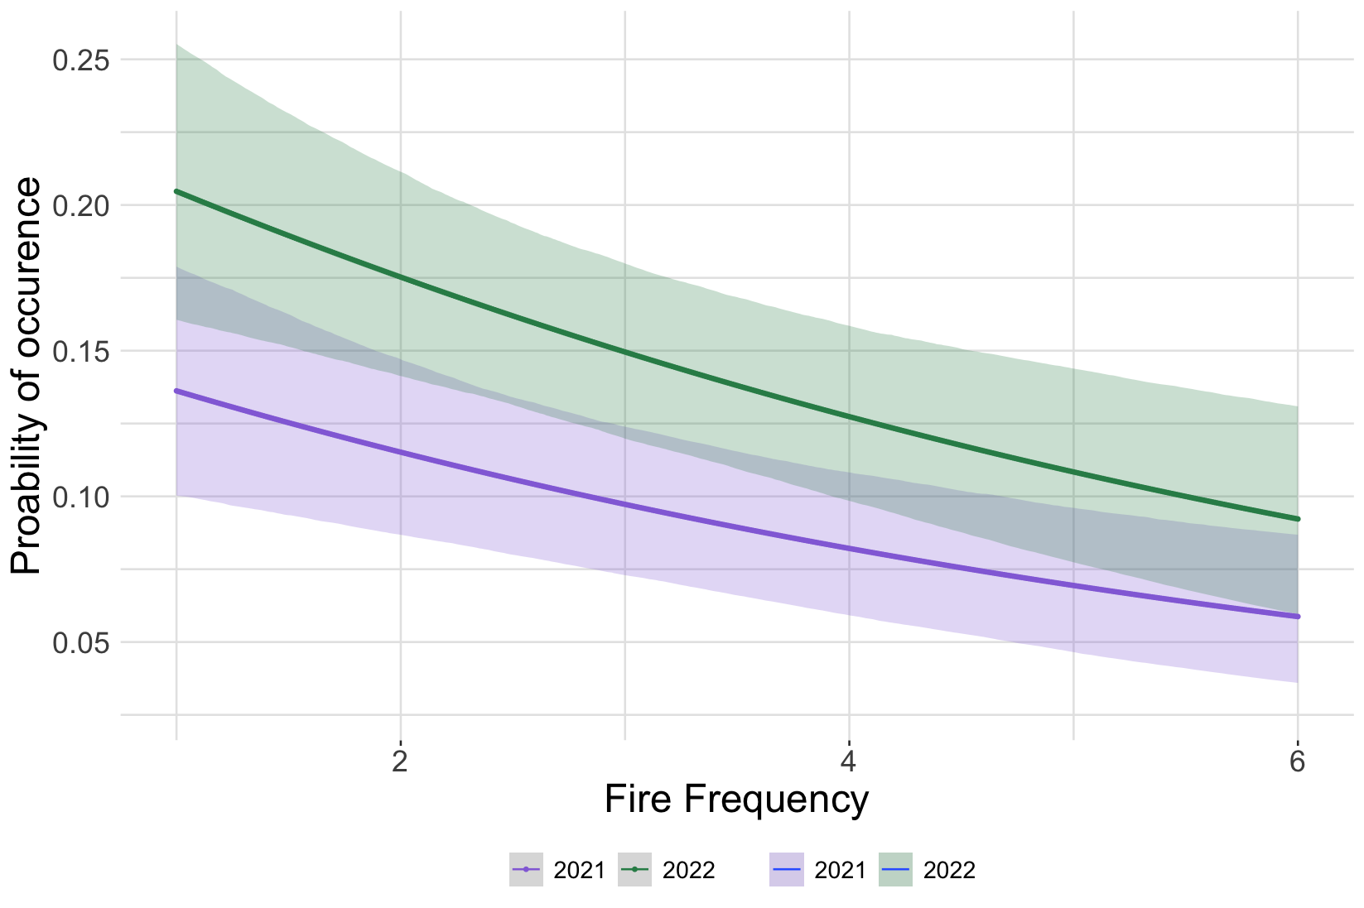

Fig 6: Probability of occurrence of an obligate seedling (A) and facultative seedling (B) decline with increased fire frequency in both survey years (2021 & 2022). Error bars show 95% CIs.

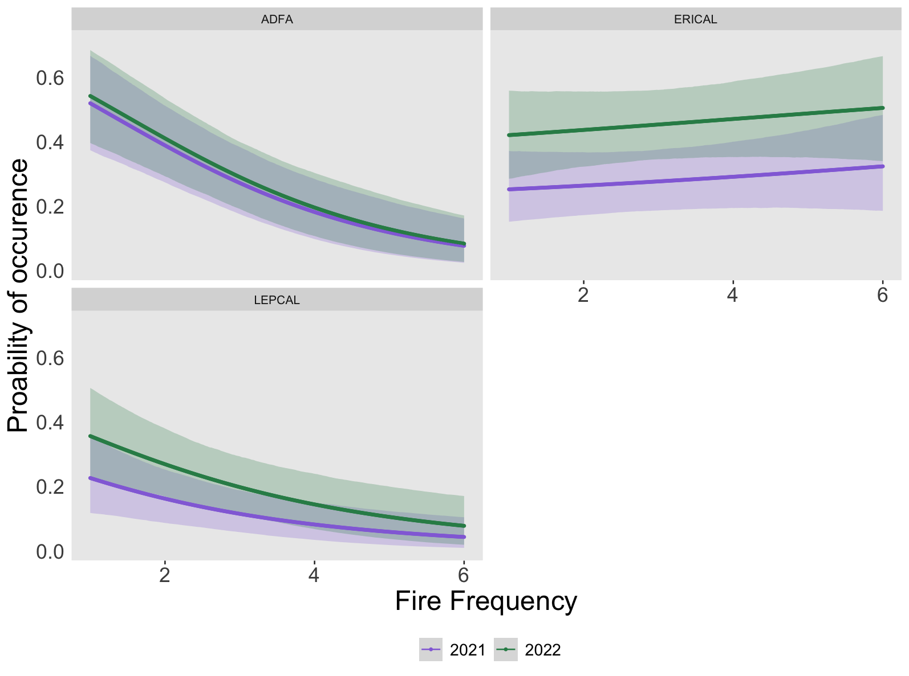

Fig 7: Probability of occurrence of *Adenostoma fasciculatum* (ADFA), *Eriodictyon californicum* (ERICAL), and *Lepechinia calycina* (LEPCAL) with increased fire frequency in both survey years (2021 & 2022). Error bars show 95% CIs.

# Discussion